A Quick Primer on the Idaho ACE Study

Adults in Idaho are more likely to have experienced abuse, neglect and a variety of serious family dysfunctions as children at a rate higher than their peers in other states. These experiences, called ACEs for Adverse Childhood Experiences, are correlated with at least 5 of the 10 leading causes of death according to the Centers for Disease Control and Prevention (CDC).

Adverse Childhood Experiences were first studied in the late 1990’s through a joint project between the CDC and Kaiser Permanente. The study found significant long term behavioral and physical health effects. Researchers surveyed over 17,000 adults specifically in three areas – abuse, neglect and household challenges. For abuse, they looked at if someone had experienced emotional, physical or sexual abuse. For household challenges they looked at growing up in a household where there was mental illness, substance abuse, incarceration of a family member, domestic violence, or divorce. For neglect, they looked at both physical and emotional deprivation.

A recent study of ACEs among Idaho adults conducted in 2018 as part of Idaho’s annual Behavioral Risk Factors Surveillance Survey (BRFSS), revealed some surprising findings:

- Nearly 2/3 (65%) of Idaho adults had at least 1 of the 10 ACEs measured by the study
- Almost 1 in 4 (23%) had 4 or more ACEs—a threshold amount for long term physical or mental health impacts

Both findings were well above the national average.

- Idaho adults were more likely to have grown up in a household with a substance abusing parent, more likely to have grown up with a parent who had a mental illness and more likely to have grown up in a household with an incarcerated member than their peers in other states;
- More than 1 in 6 was physically abused;
- More than 1 in 8 had been sexually abused.

Idaho’s numbers tell the same story that the original ACE study had revealed: ACEs are common.
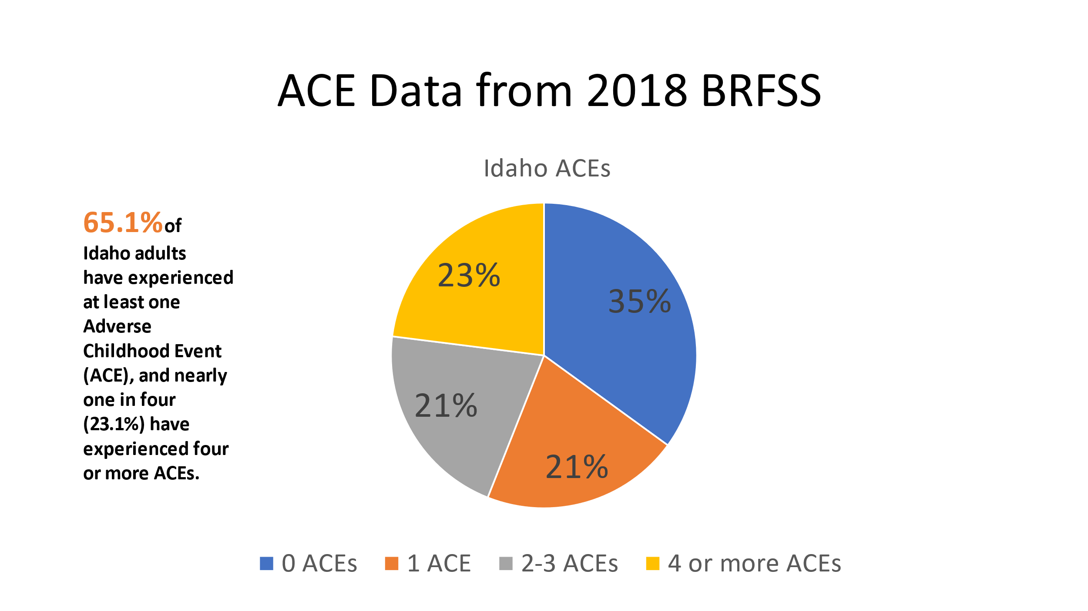

As compared to the average of 23 states’ BRFSS results, Idahoans were less likely to have zero ACEs and significantly more likely to have 4 or more (23% v. 15.8%).

The most prevalent ACE among Idaho adults was emotional abuse with over a third of respondents reporting that they had frequently been sworn at, insulted, or put down by a parent or adult in their home. Living in a household with a single parent following divorce was the second most prevalent ACE among Idaho adults.
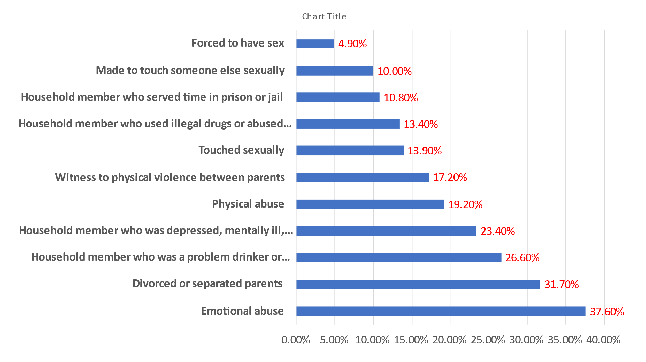
The study also found that Idahoans faced significant challenges in educational attainment and earnings as a consequence of higher ACEs scores.

The study concludes that “Raised awareness about ACEs can help shift the focus of preventive efforts from individual responsibility to community-level, public health solutions. Additionally, collecting state-level ACE prevalence data through the Idaho BRFSS and other surveys can enable further examination of relationships between ACEs and other systems, such as the foster care and juvenile justice systems, affecting Idaho children.”

