Executive Director Report to the
Board of the Idaho Children’s Trust Fund
Third Quarter SFY2021

July in Boise. I think all of us are ready to meet in person. I will be fully vaccinated by mid-May and hope the trend of the virus will be in our favor by then. So hang in. One more meeting online. Since I was not able to meet with you after the death of my mother in January, it has been a long time since I have talked to you all together. I am looking forward to it!
We have been busy. As if Child Abuse Prevention Month and the Strengthening Families Training Institute were not enough, there has been plenty on our plates this quarter! So here goes.
SFTI: It was a highly successful SFTI with over 300 people registered and attending some part of the event. I will be presenting on the evaluations at the meeting. Our partnership with the Children at Risk Task Force and sponsorship with Casey resulted in very few expenses for the Trust Fund. CARTF covered the expenses for technology and for an honorarium with Dr. Sarah Watamura. We split the cost of Corey Best and paid an honorarium to PCAA Director, Melissa Merrick for a total of $4,000.
ACE Learning Collaborative: As you heard at the last meeting, we received a $35k grant from the Maternal and Child Health division to facilitate a learning collaborative on ACEs that we hope will encourage medical practices to screen for traumatic childhood experiences. We have been setting this up throughout the quarter. Focus groups will start in May. Our plan is to have 7 or 8 focus groups with parents drawn primarily from Head Start programs statewide. 5 will be geographic, 1 will be in Spanish, and 1 will be with people from the two tribal programs. We will do an additional one with young adults who are alumni of the foster system. A parent advisory group will develop guidelines based on the focus groups and present to the physicians.
Idaho Resilience Project (IRP): In some ways the IRP is virtually an extension of the work of the Trust Fund in that we share the same goal of creating thriving communities that support families and children. I am part of the steering group or “Impact Team” that determines the group’s direction. IRP has been heavily focused on educating and building awareness around ACEs and resilience building strategies. During the quarter, the Resilient Idaho documentary was released. Now we are developing specialized watch parties to be held each month through November. The first one was at the beginning of this month with a focus on child abuse and neglect. Holly Whitworth from Idaho Falls and I were the post screening panel. Next month is focused on mental health and June will be on domestic violence. We are working on a professional development opportunity for teachers as a mini=series this fall.
Thriving Families Safer Children: We were invited to join this initiative through a consortium of the federal Children’s Bureau, Prevent Child Abuse America, Casey Family Programs, and the Annie E. Casey Foundation. 16 states are part of a cohort focusing around creating a shift in the traditional child welfare system towards a family wellbeing/prevention-focused system. I have pulled together a team made up of people from the Department of Health and Welfare, the court system, schools, and non-profit advocacy groups. This is an initiative still forming but with interesting potential given the new dollars coming into the state.
Idaho Behavioral Health Council work group: The IBHC is charged with creating a strategic plan for behavioral health in Idaho and was created by a joint resolution between the Governor, Legislature and the Supreme Court. I served on a time limited task force focused on children and had the opportunity to infuse ACE and childhood trauma information into the discussion through presentations to the working group and the overall Council. The work group forwarded recommendations focused on research and action around childhood trauma.
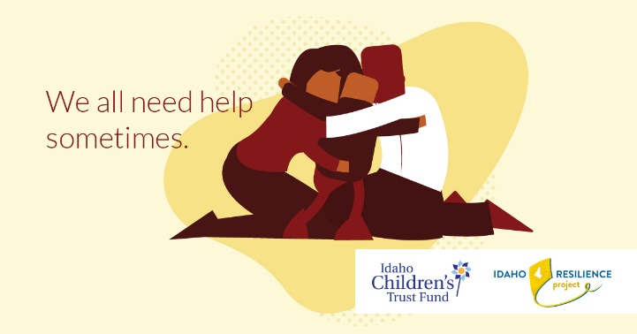
Idaho Family support.org/Press Conference: Our original $15,000 from the Valerie Chrisman memorial began what has now had 1.2 million impressions and over 6500 clicks from February 1 to March 14. I hope to have a report form the HelpNow line prior to our meeting next week.
We will discuss extending this effort as part of our thinking on the $1.5 million ARPA funds.

Stewards: Our work on sexual abuse prevention training has slowed considerably this past year. We have a small contract with Cathy Carmen to coordinate new trainings and act as a liaison with Darkness to Light to develop training opportunities for facilitators. I have also recently begun conversations with two of our Spanish language facilitators to develop plans for outreach to the Latinx community. This is a group that has been hard to reach for cultural barriers so want to create some new strategies.
Discussions re: dollars: I have been working to foment discussion around coordinating the ARPA dollars to the best benefit of kids and families. We will discuss on Monday.
I have given presentations during the quarter to the following:
- Regional Roundtables to domestic violence groups sponsored by the Idaho Council on Domestic Violence and Victim Assistance
- Workshop at Idaho Head Start Association conference
- Optum Lunch and Learn
- Out of School Network—helping develop a training curriculum to be used statewide called Relationships in the Time of Recovery
- League of Women Voters--Moscow
Fundraising: We received $10K from Optum Idaho
Public Policy: I met with Representative Lauren Necochea to talk about possible legislation for next year to focus on child sexual abuse.

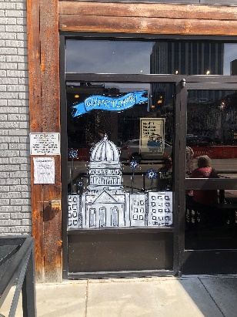
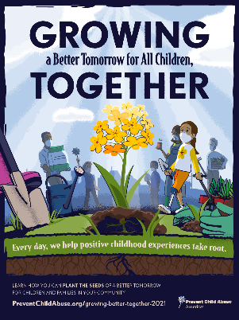
The national theme from PCAA and one of the painted windows at 10 Barrel in downtown Boise

