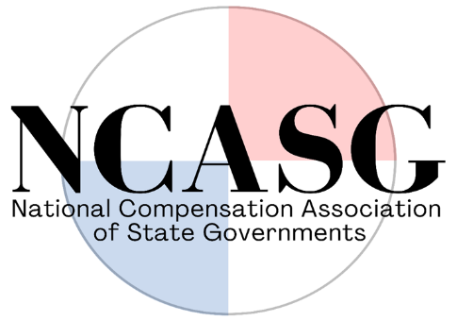

AGENDA
National Compensation Association of State Governments (NCASG)
Quarterly Virtual Meeting (Microsoft Teams)
Monday, January 9, 2022
1:30 P.M. – 3:00 P.M. CST

- Call to Order

- Membership Roll Call

- Election of Secretary/Treasurer Officer

- Consideration of the Minutes from the Business Meeting held October 12, 2022

- Executive Committee Update: Bylaw amendment presentation, Janelle Haynsworth (LA)

- Conference Committee Update: Ryan Beard (MS), chair

- Survey Committee Update: Ryan Beard (MS), chair

- Audit Committee Update: Ryan Beard (MS), chair

- Finance and Legal Committee Update: Janelle Haynsworth (LA), new Secretary/Treasurer (TBD)

- Ad hoc Committee Updates
  - Technology Survey Committee: Daniel Hearn (MS), lead

  - Website Committee: Ellen Zeller (SD), lead

- Open Floor for Additional Motions

- Adjournment of formal meeting

If there is time available after the formal meeting adjourns, members may remain on the call to network and confer about various topics.

