NATIONAL COMPENSATION ASSOCIATION
OF STATE GOVERNMENTS

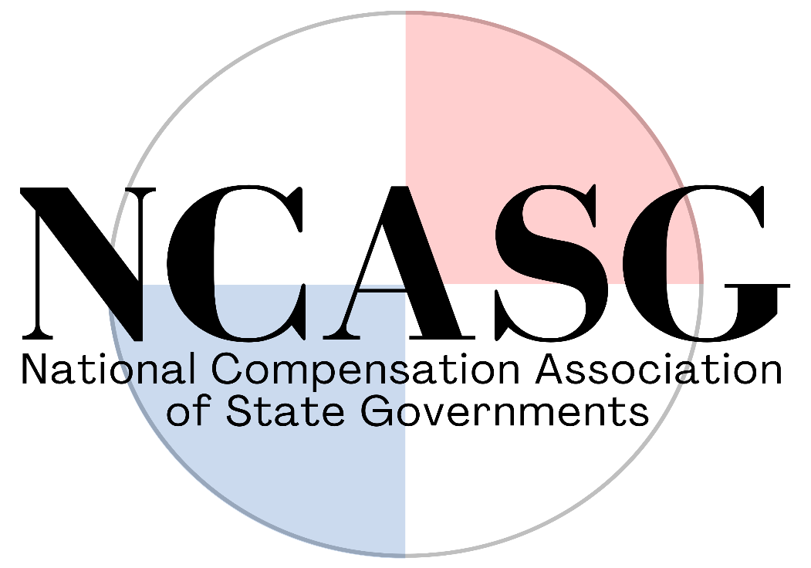

ASSOCIATION BYLAWS

Adopted: September 28, 2011
Amended: October 12, 2022

OVERVIEW

Name
The name of the organization shall be known as the "National Compensation Association of State Governments", hereinafter referred to as NCASG or Association.

History
The Central States Survey Conference, now known as the Central States Compensation Association (CSCA), was established in 1984 for the purpose of improving the validity of job matches and accuracy of data in salary surveys among the states and reducing the number of individual surveys exchanged among the states on an annual basis. Eleven states collaborated and conducted the initial survey. Since that time 15 other states have joined in the survey process and CSCA's annual conference. The states and year of initial participation are shown at right. In 1984, the states met twice to establish benchmark classes, verify matches, and analyze survey data. Since that time, the states have joined in an annual conference to ensure the continued technical quality of the survey and to share general compensation related information.

The Southeastern Salary Survey Conference (SSSC) was established in 1958 in order to conduct an annual salary survey and thus reduce the number of ad hoc surveys exchanged among southern states. Representatives from the central personnel agencies and highway personnel offices of eleven states initially met to discuss salary problems in the field of civil engineering. In 1962 representatives from these eleven states met aga in to discuss questions of a general nature in the field of classifications and pay, and with a discussion of ways and means for improving the utility of the conference. Fourteen states are now members with four also members of the Central States Compensation Association.

Approximately every three to five years a member state would host a joint conference of both organizations. This was especially beneficial to states that were members of both associations; however, through the years it became apparent that both associations had similar goals and similar methods of operation. Although there had been many informal discussions over the years regarding merging both organizations, it was not until 2010 that formal discussions commenced on merging both associations into a single national organization. On September 28, 2011, the Central States Compensation Association and Southeastern Salary Survey Conference agreed to merge and form the National Compensation Association of State Governments.

Member States and Conference Sites
A full listing of active member states, as well as past and future conference sites can be viewed at www.NCASG.org.
ARTICLE I – IDENTIFICATION

Federal Registration
The NCASG is a non-profit organization registered with the Federal Department of Treasury, Internal Revenue Service, with an Employer Identification Number (EIN). The NCASG Secretary/Treasurer will maintain a copy of the EIN for tax reporting purposes.

ARTICLE II – STRATEGIC VISION

Mission
The mission of the NCASG is to:

- Conduct a salary, benefits and pay practices survey annually and provide reports for member states; and

- Provide a forum for compensation professionals from member states to exchange information, professional expertise, and knowledge related to the compensation of state government employees.

ARTICLE III – MEMBERSHIP

Membership Categories
Regular Member
A regular member is the central human resource agency in the participating states. Each regular member agency may designate an individual to represent that state in the organization.

Associate Member
An associate member is an agency/institution in a member state, other than the central human resource agency, which has an interest in and supports the regional exchange of compensation information.

Funding
Membership Fees/Dues
Funding for Association activities is provided by membership fees. The Association will charge an annual membership fee of $400 for regular and associate members on July 1. This amount includes attendance to virtual meetings/presentations, easy access to member contacts, and one registration to the annual conference. Payment is due by August 1.

Revenue
The Association may acquire assets through conference revenues as well as through survey publication sales. Upon the dissolution of the Association, any remaining assets will be equally distributed among all state members.

New Membership

Application for Membership
A central human resource agency of a state may apply for regular membership by submitting a written request to the current President of the Association. The request must indicate the state's agreement to support the Association's mission. An agency, other than the central human resource agency of a member state may apply for associate membership by submitting a written request to the current President of the Association.

Approval of Membership Application
The Executive Committee will determine whether to accept the membership by majority vote. The Executive Committee shall consider:

- The level of commitment by the state to support the Association's mission, and

- The orderly growth and ability of the Association to administer the added data exchange.

Discontinuing Membership

Resignation
Any regular or associate member agency may discontinue their membership by written notification to the President.

Removal
The Association may, by majority vote at the annual conference business meeting, remove a member (regular or associate) who does not provide support for the Association mission.

ARTICLE IV – OFFICERS

General Powers and Duties
The affairs of the Association shall be managed by its Officers. The Officers, with the assistance of individuals designated to represent each regular member agency, shall be responsible for the operation and continuance of the Association. The Officers shall have the responsibility for interpretation of NCASG's bylaws.

Selection and Term of Office
The officers shall consist of a President, President-Elect, Past-President and Secretary/Treasurer. The President-Elect and Secretary/Treasurer shall be elected by majority vote of the membership at the annual conference business meeting. The officers shall serve one year-terms ending at the adjournment of the annual conference.

President
The President shall perform the usual duties of a presiding officer at meetings of the Association. The President shall serve on or appoint committees as directed by the membership of the Association and may appoint special committees as deemed necessary. The President shall be the contact person for all business relating to the Association with the exception of financial matters. The President may make business proposals and make decisions based on simple majority voting.

President-Elect
The President-Elect shall perform such duties and serve on such committees as may be assigned by the President and/or the Association. The President-Elect shall succeed the President at the end of the President's term or in the event that the President resigns or is unable to serve. In the case of temporary absence of the President, the President-Elect shall serve in the place of the President.

Past-President
The Past-President shall serve as an Officer for a period of one year immediately following such year of service as President, and shall provide counsel and assistance to the President and perform special assignments and such other duties as the President may deem necessary and authorize.

Secretary/Treasurer
The Secretary/Treasurer shall oversee the preparation of all minutes, records, and membership rolls for the Association. The Secretary/Treasurer shall notify members of meetings and prepare and distribute the meeting agenda and the minutes of the previous meetings. In the absence of both the President and President-Elect, the Secretary/Treasurer shall serve as President. The Secretary/Treasurer shall oversee any collection of dues/fees and maintain the statement of accounts and any disbursements of funds. The Secretary/Treasurer shall report to the Association the financial status of the Association, and if necessary, prepare financial reports for the Association.

Note: The Secretary/Treasurer and the President or their designees shall be authorized to deposit and withdraw funds from the checking account established for the NCASG.

Nondiscrimination
The qualifications for holding office will be defined without regard to age, sex, race, religion, national origin, sexual orientation, or other factors prohibited by law.

Qualification
A regular member is the central human resource agency in the participating states. Each member agency may designate an individual to represent that state in the organization. Only a representative designated by a member agency shall be eligible to hold office.

Resignation
Any regular or associate member agency may discontinue their membership by written notification to the President.

Removal
The Association may, by majority vote at the annual conference business meeting, remove a member (regular or associate) who does not provide support for the Association mission.

Vacancies
Any vacancy occurring in an Officer position by reason of death, resignation or removal, shall be filled by the Officers, or by the affirmative vote of the majority of the remaining Officers, although less than a quorum may be present, or by a sole remaining Officer, at a special or regular meeting. The Officer elected to fill a vacancy shall hold office until the next election of officers. A vacancy that will occur at a specific later date, by reason of a resignation at a later date, may be filled before the vacancy occurs, but the new officer may not take office until the vacancy occurs.

Common Disaster
If following a vacancy in the officers there are no remaining officers, three persons who have most recently served on the Executive committee shall become officers. Those persons shall prepare a slate of proposed officers (which slate may include such persons) and the slate of nominees shall be presented to the membership for their approval at a special election. If the officers are elected at a meeting of the members, additional candidates may be nominated from the floor at such meeting.

Standard of Conduct
An officer shall discharge his or her duties, including those duties as a member of the Executive committee, and including but not limited to the duties of such member as a member of a committee, in good faith, with the care an ordinarily prudent person in a like position would exercise under similar circumstances, and in a manner the officer reasonably believes to be in the best interests of the NCASG. In discharging his/her duties, an officer is entitled to rely on information, opinions, reports, or statements, including financial statements and other data, if prepared by a regular member designee or presented by any of the following: (i) legal counsel, public accountants, or other person as to matters the officer reasonably believes are within the person's professional or expert competence; and (ii) a committee of or appointed by the President of which the officer is not a member if the officer reasonably believes the committee merits confidence. An officer is not acting in good faith if the officer has knowledge that makes reliance on any of the above unwarranted. The creation or delegation of a committee of the Executive committee does not alone constitute compliance with an officer's standard of conduct.

ARTICLE V – COMMITTEES
Members of all committees shall hold office until the adjournment of the annual meeting marking the end of their term. Vacancies on any committee shall be filled by the President.

Executive
The Executive Committee of the Association shall consist of the President, President-Elect, Secretary/Treasurer, and immediate Past President. A representative of the state hosting the upcoming conference shall be a fifth member of the Executive Committee if that member state's representative does not hold one of the above offices.

The Executive Committee may meet as necessary to plan Association activities and conduct any business on behalf of the Association.

The Executive Committee shall be responsible for the annual review of the mission, goals, and objectives of the Association and shall present any recommendations for discussion and resolution to the general body at its annual meeting. The Executive Committee shall also be responsible for ensuring that members are selected to host the annual conference and conduct the salary survey, the benefit survey, and the pay practices survey.

Conference
The Conference Committee shall consist of the current host state (who shall serve as chair), the immediate past host state, and the President. The Conference Committee shall be responsible for all of the arrangements for the annual conference.

Survey
The Survey Committee may include from three to five members and shall consist of the President-Elect (who shall serve as chair) and the state that conducts each of the salary, benefits, and pay practices surveys. If the state conducting one of the surveys changes, the state that last conducted that survey shall also serve on the Survey Committee.

The Survey Committee shall be responsible for administration of the surveys according to the procedures established by the Association. The Committee shall also recommend addition or modification of survey procedures to the membership at the annual conference. The states conducting the Salary Survey, the Benefits Survey, and the Pay Practices Survey are each responsible for distribution to the survey participants.

The Survey Committee is also responsible for quality control of the surveys. Each year the Committee will review responses to benchmarks, proposed new classes to the survey, benchmark descriptions, and state responses to ensure that the data provided is the most accurate description of the state government labor market.

Audit
The Audit Committee shall consist of the immediate Past President as the chair, the Secretary/Treasurer, and one other member appointed by the Executive Committee. The Audit Committee is responsible for auditing the finances of the Association and reporting to the Executive Committee.
Finance and Legal
The Finance and Legal committee may include from two to five members and shall consist of the Secretary/Treasurer (who shall serve as chair), the President and the host state coordinator and will be responsible for the financial and legal operations of the Association.

Ad-Hoc
Ad Hoc Committees may be established by the President as necessary or as directed by the membership.

ARTICLE VI – MEETINGS/CONFERENCE

Annual Conference
The Association shall hold an annual conference to conduct Association business and to report and exchange compensation information. The time and place of the annual conference shall be determined by majority vote of the membership at the annual conference.

Registration Fees - Waived
Conference registration fees shall be waived for the following members: President, President-Elect, Secretary/Treasurer and three staff members from the state hosting the upcoming conference.

Registration Stipend - States Conducting Surveys
One staff member from each of the states responsible for one of the three Association surveys – the Salary Survey, the Benefits Survey, and the Pay Practices Survey – may formally request from the Executive Committee to each be provided a stipend to be used to cover registration fees, lodging and/or travel to the annual conference.

Free hosting registrations shall be shared if more than one state sponsors an annual conference. Pending available funds, the President shall propose any revision to the free registration/stipend policy.

Committee Meetings
Meetings of the Executive Committee, Conference Committee, Survey Committee, Audit Committee, and other special ad hoc committees may be held in conjunction with the annual conference, by conference call, or otherwise, as necessary.

Special Meetings
Special meetings may be called by or at the request of the President or Committee chair.

Attendance by Communications Equipment
Members of the Executive committee or of any committee of the Association may participate in and act at any meeting of such committee through the use of a conference telephone or other communications equipment by means of which all persons participating in the meeting can hear each other. Such meeting shall constitute attendance and presence in person at the meeting of the person or persons so participating.

Quorum
A simple majority of current members present at the annual conference shall constitute a quorum for the transaction of Association business at the annual business meeting. A simple majority of current members assigned to serve on a standing or special committee shall constitute a quorum.

Parliamentary Procedure
Meetings of the members, officers and committees of the Association shall be conducted in general conformance with the rules contained in Robert's Rules of Order (Newly Revised) in all cases to which they are applicable, except as otherwise provided in the bylaws.

ARTICLE VII – ANNUAL SURVEY AND REPORT
The Association shall decide the scope of the annual surveys. The annual Salary Survey, the Benefit Survey, and the Pay Practices Survey shall each be conducted by member states on a volunteer basis as determined by the membership at the annual conference.

Member Participation
Participation in the surveys is a prerequisite to receiving the survey data and reports at no charge. Any state not participating in the survey(s) must purchase the survey reports at the price charged for non­member purchase unless the fee is waived by the Executive Committee.

Sale of Surveys
The Association shall decide the purchase price for the survey publications. All invoice and billing shall be administered by the Secretary/Treasurer.
Copyright
The reports of the annual National Compensation Association of State Governments Salary, Benefit, and Pay Practices Surveys shall be copyrighted documents. Although most or all individual data in the survey reports are public information, the Association intends to protect the gathering and assembly of the data into one format.

ARTICLE VIII – BYLAW AMENDMENTS
These Articles of Association and any amendments hereto may be adopted, amended, or repealed at any time by either a majority vote of the entire Executive committee at which a quorum is present or a majority vote of regular members present at the annual meeting of the Association.

I, ___________________, the duly elected, qualified and acting Secretary-Treasurer of the Association, do hereby certify that the above and foregoing are the amended and restated bylaws of this Association as adopted by the membership effective October 12, 2022.

