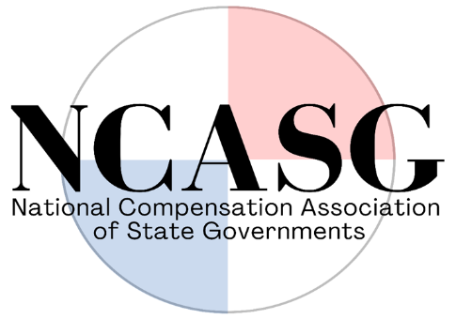

AGENDA
National Compensation Association of State Governments (NCASG)
Quarterly Virtual Meeting (ZOOM)
Monday, April 10, 2023
1:30 P.M. – 3:00 P.M. CST

- Call to Order

- Executive Committee Roll Call:
  - Janelle Haynsworth (LA), President
  - Paul Christianson (MN), President-Elect
  - Terry Pickett (CO), Secretary/Treasurer
  - Ryan Beard (MS), Past President

- Welcome to the newest member-state, Maine!
- Kelsie M. Lee, BHR Compliance Director
- Thaddeus Cotnoir, Compensation

- Listserv email update: Janelle Haynsworth (LA)

- Conference Committee update: Ryan Beard (MS), chair
  - Save the date! October 1-4, Embassy Suites in Ridgeland, Mississippi

- Finance and Legal Committee Update: Terry Pickett (CO), chair
  - Electronic payment methods

- Ad hoc Committee Updates
  - Technology Survey Committee: Daniel Hearn (MS), lead
Initial meeting 3/31

  - Website Committee: Ellen Zeller/Geno Adams (SD), lead
Website revisions

- Open Floor for Additional Motions

- Adjournment of formal meeting

Informal discussion:
- Correctional Officers: Doug Pine (VT)

If there is time available, members may remain on the call to network and confer about additional topics.

