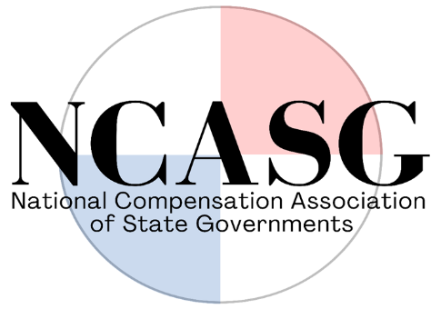

AGENDA
National Compensation Association of State Governments (NCASG)
Quarterly Virtual Meeting (Microsoft Teams)
Monday, January 9, 2022
1:30 P.M. – 3:00 P.M. CST

- Call to Order

- Membership Roll Call
  - State members entered their presence in chat
  - Executive Committee members present:
    - Janelle Haynsworth (LA), President
    - Paul Christianson (MN), President-Elect
    - Ryan Beard (MS), Past President

- Election of Secretary/Treasurer Officer
- Terry Pickett (CO) Appointed and Seconded

- Consideration of the Minutes from the Business Meeting held October 12, 2022
- Minutes accepted

- Executive Committee Update: Bylaw amendment presentation, Janelle Haynsworth (LA)
  - By Laws Overview – Website updates, New Logo, 2011 version tables outlining member states, Federal tax ID, addition of membership fee (this is new)
  - Membership cost is $400 annually and will begin July 1, 2023 – State as a whole, not individual
  - States will have a new fee for membership, any pushback from budget?
  - Ways to get different forms of payments online
  - Secretary/Treasury role is changing regarding conference registrations, collections of dues and fees, sign off
  - Janelle Haynsworth (LA) motioned to approve the bylaw amendments and the motion was seconded by Paul Christianson (MN)

- Conference Committee Update: Ryan Beard (MS), chair
  - Mississippi Hosting – Not in Jackson, scheduled for October

- Audit Committee Update: Ryan Beard (MS), chair
  - Monitoring compliance and bylaws – No update

- Finance and Legal Committee Update: Janelle Haynsworth (LA), new Secretary/Treasurer
  - No Updates – typically done at the conference

- Ad hoc Committee Updates
  - Technology Survey Committee: Daniel Hearn (MS), lead
No updates yet

  - Website Committee: Ellen Zeller (SD), lead
No updates yet

- Open Floor for Additional Motions
  - None

- Adjournment of formal meeting

Members remained on the call to network and confer about various topics, which included:
  - States are looking at pay structures changes
  - Most states will be adjusting pay ranges
  - Problems updating pay because of the lead/lag in the market
  - States are looking at giving 3-6% increases
  - States are increasing pay ranges by 3-5%
  - Most legislatures are approving the increases to attract talent and retain current employees
  - Looking at equity at different ways, compression and what are they looking at for guides
  - Raising retirement contributions by the State of Colorado
  - More unions showing up
  - Tough labor market
  - Creative ways to attract new talent
  - Applications are low

