RMIS: Turn ON Compatiblity View by checking Compatibility View under tools. This will activate the Compatibilty View icon in the address bar. The icon will be BLUE which means it is is ON, (Gray means OFF).
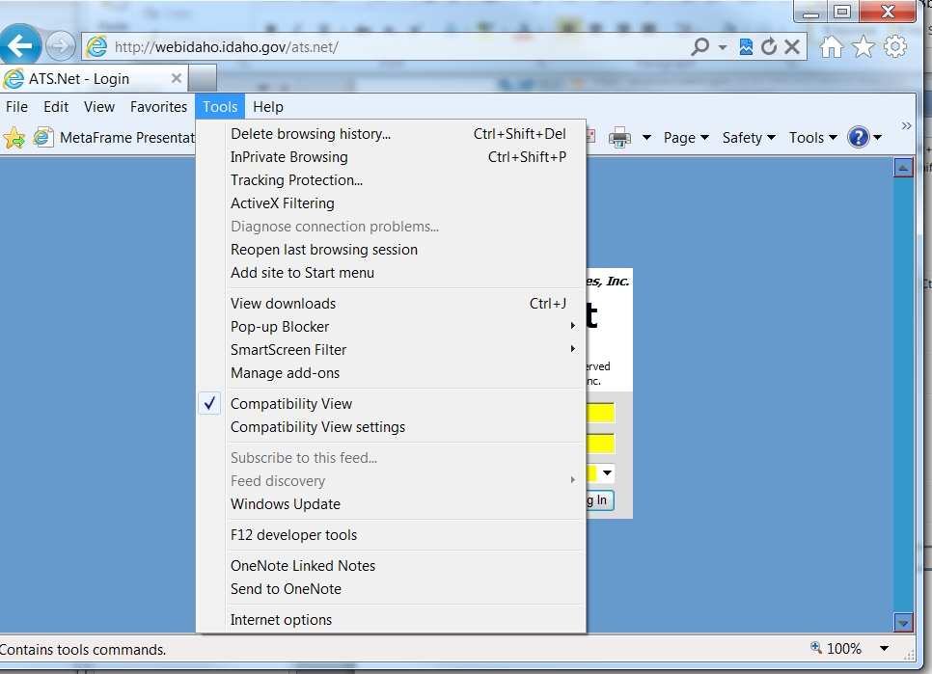
SCO: Turn OFF Compatiblity View by UN-checking Compatibility View under tools, or another method is to click the blue Compatibility View icon which then turns gray (Gray means OFF).
