Human Resource Statewide Call
April 6, 2023
2pm MST

Janelle White
Senate Bill 1191 (CEC, Telecommuting)
This bill did not go anywhere this session, but still important to talk about. This bill came up at the very end of the session. The sponsor proposed legislative statute changes that would make it so agencies could not early implement CEC, and so that agencies could only have a maximum of 15% of their workforce telecommuting. The bill was printed, but not assigned to a committee. Lori had conversations with legislators and the governor’s office, and they will put together a committee to review the concerns that are brought up. Concerns were that the public was not receiving good customer service from the employees that are telecommuting. We will look and see where we can put together some guidance. –
- Don’t know for certain, but fairly confident that this will be the last year that we are able to implement CEC early, and in the future, it will have to be at the beginning of the fiscal year. Agencies will need to use salary savings throughout the year and not hold them for early implementation. We will continue to keep you updated as more information becomes available.
Senate Bill 1054 (PERSI Return to Work)
DHR sent out email last week with some information on this bill. It is similar to last year for PERSI reemployment to return to work while still receiving retirement benefits. There was a modification to the statute which is specific to police and firefighters with a few different provisions. Michelle did draft policy and we are working through what it will look like. For those agencies with police and firefighters, we are still working through finer details of what it will look like. Will have more info in coming weeks, but please reach out to DHR central if you have questions. One requirement or the change is that an agency cannot make guarantees that an employee can return prior to retiring, this guarantee would render them ineligible. Statute says police officer and firefighters…still vetting if applies to corrections.
Director’s CEC Guidance
We were hoping to get guidance from the Governor’s office last Friday but wrap up for the session took precedence. We are hoping to have guidance from them tomorrow. It should be similar to last year, where a board or commission is in place, they will make recommendations to the governor’s office. For appointments, the governor’s office will do an evaluation and make a recommendation for a CEC. If you have questions, just give Janelle a call.
Strategic Planning Priorities
About a month ago, DHR did some strategic planning work to help prioritize the work. The priorities are Modernization and Luma. We drilled down further into more specific things that must be done by the end of the fiscal year. For modernization, we came up with: Summit and onboarding. It is an opportunity to bring people together and do some development, and to do a new employee onboarding to orient people to policy and procedures. Another one is the logistics for onboarding all the employees and welcoming them to DHR. We are working on finalizing the organizational charts for field staff. We are also working on a service level agreement between DHR and agencies which will outline responsibilities and services of who will be responsible for what and what the service standards will be to agencies. Taryn has been working really hard on system access. We have decided to have employees stay with their current agency email address, makes it easier to access information within the agency, rather than being switched to DHR. We will still be working on how to access DHR Office 365 and the Teams site as well as SharePoint. Next quarter we will be finalizing the classification review with the next steps.
- If you can make it to the summit, please prioritize it. This will be a very important couple of days and will be informational on how things will move forward. It is also a great opportunity to get to know your new teams.
April 27- Bring Your Child to Work Day
April 27 is bring your child to work day and the Governor’s office wants to support state employees in this day. Lori is having conversations with the Governor’s office on how to support the day. Some ideas that are being discussed are bring kids to capitol event. Once we have more information from the Governor’s office, we will be sure to share it out.

Michelle Peugh
FY2024 Legislative Tracking Next Steps
Session has ended! It was long but very successful. We tracked 50 bills that we thought would have some impact on the work that we do. We will debrief internally and decide the impacts then get the information out to everyone. Please Remember, rule and statute changes do not take effect until July 1. The biggest thing to remember is to keep hiring from top 25 lists for recruitments and that equity increases still require a performance evaluation until July 1.
- Janelle White gave kudos to Michelle for her work with the legislature. Janelle stated that at times, it can be a tough crowd to present to, but Michelle did a great job.

Out of State TC for Oregon Update
The State of Oregon is implementing family medical leave insurance which will be funded by employee and employer. Starting in September, this leave will provide employees with paid time off up to12 weeks. It expands FMLA qualification to include sexual assault, harassment, stalking, and domestic violence. It will apply to employees that live and perform work in the state of Oregon. DHR is working on gathering information on how many employees meet those qualifications. We will be reaching out to agencies to find out which employees live and work in Oregon. The fiscal impact is small, it would equate to 1% of the employee’s salary, where the employee pays 60% and employer pays 40%. In addition, from an HR standpoint, there are no policies or training on how to certify people for the new qualifications.
- The hard part of this will be the administration of the changes, not the fiscal impact. DHR would have to create policy and forms and know how the Oregon Department of Employment will approve the requests. Agencies need to prepare their Executive team that employees working in Oregon, may not be able to work from Oregon anymore.

Janna Huffaker and Claire Russell
Cyber Security Completion Statuses
As of Tuesday morning over 17,000 people have completed their cybersecurity training, which equates to 92% completion rate statewide. There are 59 agencies that opt into cybersecurity training. Of those agencies, 48 are at a 90% completion rate and 23 agencies are at a 100% completion rate. There were dramatically reduced login issues this year, so thanks to agency staff for helping to communicate to employees. The next steps are to remind your employees that have not completed the training that they still need to complete it. They can still go into KnowBe4 and complete the training as past due. Please also remember to get new employees in the system so they can complete the training when they are hired. If you have any questions, please send them to cybertraining@dhr.idaho.gov. If you send questions to ITS or KnowBe4 they will be rerouted to the DHR email address, and will be slightly delayed, so please be sure to email DHR directly for the quickest response time.
Training Schedule
All DHR classes are out on DHR website. As many of you have noticed, many of the classes are full, but if you have any employee that wants to be in a class, just reach out to Jana or Claire and we can get them on the waitlist. The training team is working through completing the training. On a positive note, CPM is set to graduate at the end of June with 89 graduates in this cohort.
- Shoutout to the graduates on this call Rachelle Armstrong, Angie Baker, and Lisa McIntosh

Jennifer Pike
Open Enrollment
Open enrollment for medical, dental and FSA is right around the corner. Jennifer is actively updating the website and putting together information. There will be different offerings for SCO agencies and non-SCO agencies. Information is still coming in but stay tuned as Jennifer will send out emails with the updated information. Open enrollment dates are April 24-May 12. Once big is a change in EAP provider to BPA Health. BPA is an Idaho-based company and they offer a much broader network of services. Their contract will start July 1

Janelle McDonald and Courtney Butler
PUMP and PWFA Act
Last month Janelle sent a few emails regarding the new acts. They are very similar to what we have already been doing in the state of Idaho, but they expand coverage to include teachers and nurses. The PUMP Act is an expansion of FLSA and is through the Federal DOL. The act expands break times for nursing mothers as well as a private space. Janelle is currently looking at including this information into the current FMLA and ADA policies.
The Pregnant Worker’s Fairness Act is being pushed out through the EEOC. This act offers fairness for pregnant workers or those that have complications of pregnancy at work. Stay tuned for additional information that will be coming out in the coming weeks. In the interim, if you have any questions, please contact Janelle McDonald.
Training Update
The ADA 101 training was previewed with HROs in February. There is a training next Tuesday and is catered to agencies that do not have an HRO. If not on the list for this training, there will be more training in the next fiscal year. If you have a group of people interested in the training or want personalized training, please reach out to Janelle McDonald.
There is a Safety and Work Comp 101 training that is currently scheduled for April 25. This training is for a selected group of people who will be responsible for work comp and safety. Courtney will be hosting more training in the fall for everyone to attend if they are interested. This training will be co-facilitated by Courtney Butler and SIF. If you have any questions, please contact Courtney Butler.

Hanna Hall, Sharon Duncan, Andrea Ryan
New DHR HRIS Analyst
For those that have not heard, Racheal Hall leaving DHR on April 21. We greatly appreciate all the work that Racheal has put in and wish her well in her next endeavor. DHR has hired Jeni Lang as the new HRIS Analyst, and she will be starting April 17.
Strategic Planning Priorities
As Janelle mentioned, Luma was identified as one of the strategic planning focuses. We have been working hard and will continue to do so in order to get them completed in the next few months. Some of those priorities are developing a glossary of common terms, identify and define core functions in the system, develop business processes, provide information on the “why” behind the processes that were developed, and to develop expert user training. The Luma team is on track to meet these priorities.

Luma Updates
The glossary fir HR, WFM and payroll is almost ready. Once it is ready, we can share it out in the May training. The glossary looks at identifying a common language and offered what the terms were in the legacy system. Hanna shared that they are working on a document for required fields in luma, as many are marked as not required, but actually are required. There has been an update to the freeze dates. The system access will be open 6/20 rather than 6/19, as that day is a holiday. DHR has defined the main modules that will be the focus for training. The training will be done by DHR staff, but there will be some from the SCO training team.
- There will be training on Performance and Goals, but it will be after go live. If you have employees that need an evaluation before that module goes live, there are still ways to complete the evaluation and load the rating into the new system.
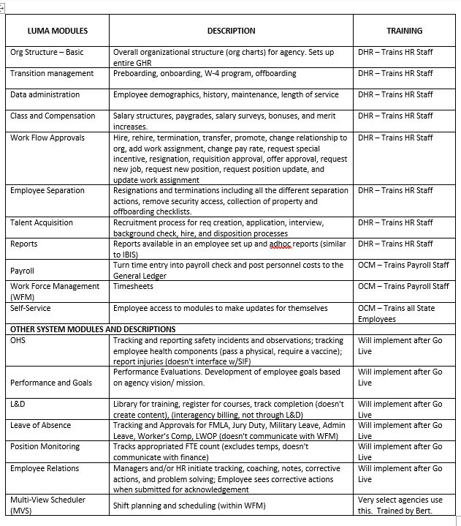

Luma Expert Users
10 people were selected to receive additional training. Those individuals are Keri Norton, Anna Pace, Donna Fox, Cody Carlson, Krystan Thompson, Erin Floyd, Lisa Lockard, Rebecca Pearson and Dallas McMurry. The Welcome meeting starts tomorrow. The training will be for an HR Generalist role and for recruiting. We are excited to have early adopters that can help with the system and provide support for field staff as we implement. We don’t have specific plan on how to use the expert users, but we them to be able can help and support as we transition. The training demos will be recorded. They will be held on Tuesdays and Thursdays.

