Defaulting on Job Postings:
As of April 25th, the EEO/Veteran/ADA information is going to default on your job posting, please remove that information from your posting so that it is not a duplicate, they are also releasing a nicer print version of the posting.

Recruitment Closeout Automation:
We’re excited to announce that the new Recruitment Closeout Automation feature will allow you to do just that, saving you a lot of time by simplifying the process.
As an Insight user, you’ll have the option to close out recruitment after authorizing a hire, or you can initiate it from the exam plan details page at any time by clicking on the new Closeout Recruitment button.
If you have any hires pending authorization, you will need to authorize those before you are able to use the automated closeout feature. Authorizing your hires helps to ensure your reporting data and time-to-hire metrics are accurate.
The automated recruitment closeout feature will allow you to perform all of the following actions:
- Update requisition status to filled or canceled
- Inactivate the job posting
- Archive the job posting, exam plan, eligible list(s), and referred list(s).
- Lock the referred list (if you use this feature).
- Send a customized reminder email to your hiring manager if there’s information you want to communicate related to closing out the recruitment.
- Update the status message that applicants can view in their profile to “Position Filled” or something of that nature to let them know that the selection process has concluded.

Note: You may not see all of the above options if these actions have already been performed. If the Recruitment Closeout button does not appear on your exam plan or you are not prompted to close out recruitment after authorizing a hire, it’s because there are no closeout activities to perform.

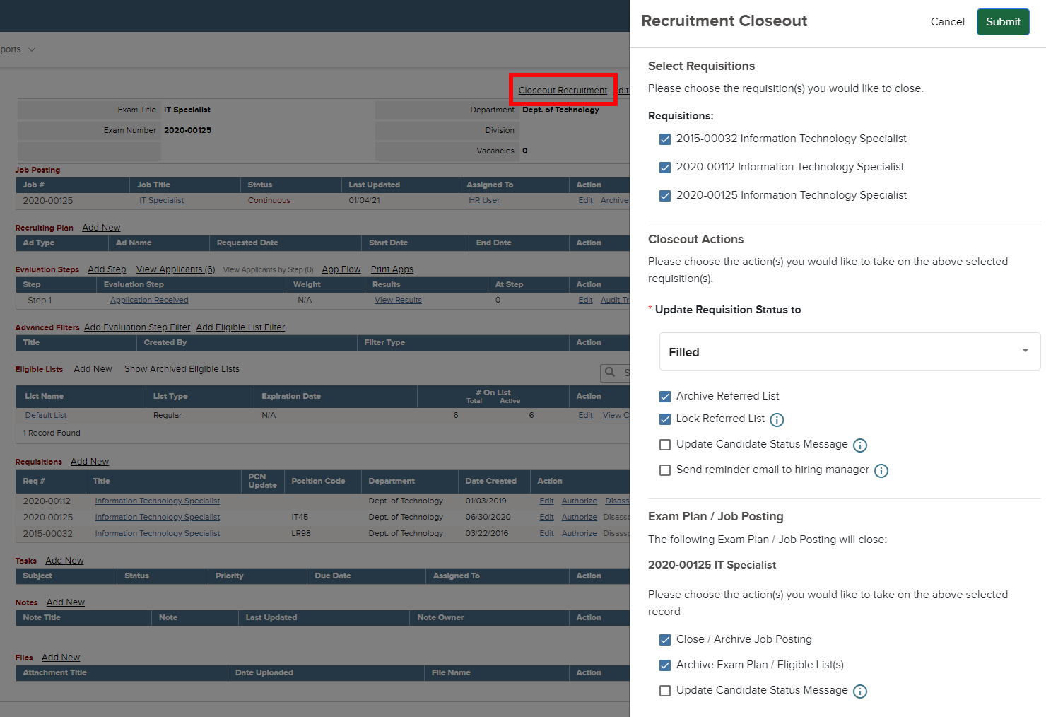

Insight Modernization:

Our major initiative to modernize Insight and the Online Hiring Center (OHC) continues with this release. Our primary goal with this initiative is to improve the overall user experience and to upgrade to the latest technology, resulting in a more modern and consistent look and feel throughout the entire NEOGOV product suite.

With this Spring release, all the OHC pages have undergone modernization and are ready for the general launch. OHC Users will notice a fresh look and feel of OHC but the functionality remains unchanged.

The following Insight pages have been updated as part of the modernization initiative and will be included in this release. We have updated the user interface (UI) and made some minor usability improvements like new sorting and filtering options on grid pages. However, the overall functionality remains largely unchanged.
Insight List Pages | Navigation
Positions List | Insight Dashboard → Jobs Menu → Positions
Oral Exams List | Insight Dashboard → Tests Menu → Oral Exams
Performance Exams List | Insight Dashboard → Tests Menu → Performance Exams
Written Exams List | Insight Dashboard → Tests Menu → Written Exams
Rater and Proctors List | Insight Dashboard → Tests Menu → Raters and Proctors
Test Locations List | Insight Dashboard → Tests Menu → Test Locations

Insight Admin Pages | Navigation
Admin Settings Landing Page | Admin
Agency Preferences | Admin → Agency Preferences
Agency Information | Admin → Agency information
Salary Import and History | Admin → Salary Import and history
Agency Password Preferences | Admin → Agency password preference
Department Approval groups | Admin → Department Approval groups and add/edit
Benefits List | Admin → Benefits

Insight Admin Configuration Settings | Navigation
Configuration Settings | Admin → Configurations settings
Security Roles | Admin → Configuration Settings --> Security Roles and add/edit
Score Calculation | Admin → Configuration Settings --> Score Calculations
Testing Preferences | Admin → Configuration Settings --> Testing Preference
Login Time Rules | Admin → Configuration Settings --> Login time rule and add/edit
Exam Plan Configuration | Admin → Configuration Settings --> Exam plan
Application Fields | Admin → Configuration Settings --> Application fields

Insight Admin Definition Tables | Navigation
Definition Tables Landing Page | Admin → Definition tables
Bargaining Unit | Admin → Definition tables --> Bargaining unit and Add/edit
Eligible List Type | Admin → Definition tables --> Eligible list type
Exam Type | Admin → Definition tables --> Exam type
Locations | Admin → Definition tables --> Locations and add/edit
Physical Class | Admin → Definition tables --> Physical class and Add/Edit
Ad Name | Admin → Definition tables --> Ad name and Add/edit
Occupational Group | Admin → Definition tables --> Occupational group and add/edit
Attachment Type | Admin → Definition tables --> Attachment type and add/edit
Search Location | Admin → Definition tables --> Search location and add/edit
Application Template List | Admin → Definition tables --> Application template list
Job Type | Admin → Definition tables --> Job type and add/edit
Geographic Area | Admin → Definition tables --> geographical area and add/edit
Eligible Sublist Type | Admin → Definition tables --> Eligible sublist type and add/edit

