**Payroll Reports**

**Pre-Payroll Cycle Reports**

1. **Bank Details** *(Resource Mainenance > Bank Details)*
2. **Employee Deductions** *(Deduction Maintenance > Employee Deductions)*
3. **One Time Deductions** *(Deduction Maintenance > One Time Deductions > One Time Deductions)*
4. **Employee Time Records** *(Time Record Processing > Time records)*
   1. *Current tab are time records processing on this payroll*
   2. *Approved tab are time records that have gone through the approval workflow and are waiting to be moved to current*
   3. *Closed by Payroll are time records that have processed on prior payrolls*

**Payroll Cycle Reports (Cycle Processing and Time Record Processing)**

1. **Missing Time** *(Emailed)*
2. **Created and Calculated Overtime** *(Cycle Processing > Overtime > Created Overtime)*
3. **Payments** *(Cycle Processing > Payments)*
4. **Payroll Checks** *(Cycle Processing > Payroll Checks)*
5. **Payroll Distributions** *(Cycle Processing > Payroll Distributions)*

**Payroll History Reports**

1. **Payments** *(Reports > Payments)*
2. **Payroll Checks** *(Reports > Payroll Checks)*
3. **Posted Payroll Distributions** *(Reports > Posted Payroll Distributions)*
4. **Wage History** *(Reports > Wage History)* ***Note: Broken***
5. **Deduction History** *(Reports > Deduction History)* ***Note: Broken***

**Adding Pay Period Hours to the Payments Report**

1. Select the 3 dots in the upper right.
2. Select Options > Personalize > Create or Update
3. On the personalization screen, select Add > Add Field

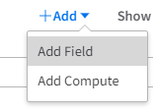

1. In the new field, click Advanced Search

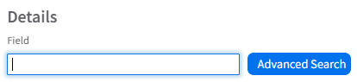

1. In the Depth and Relations search field, select “Max (Four Levels and Relations)”

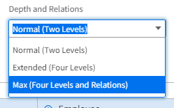

1. In the Name Search field, type EmployeePaymentTimerecordRel.Hours
2. Select this line



1. In the field details on the right, change “first” to sum

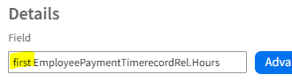



1. Select Ok