Information Technology Resource Management Council (ITRMC)

Enterprise Guidelines – G300 INFORMATION AND DATA

Category: GXXX – Methodology for Recognizing a TIM Framework Dataset

contents:
I. Definitions
II. Rationale
III. Guideline
IV. Procedure Reference
V. Contact Information
Revision History
VI. Appendix

I. DefinitionS
  - Authoritative Source – An entity authorized by a legal authority to develop or manage geospatial data or the source data used to develop geospatial data for a specific business purpose.

  - Authoritative Data – Officially recognized geospatial data that can be certified and provided by an Authoritative Source.

  - Best Available Data – Geospatial data available for distribution with no access restrictions, accurate and current at the time of compilation, and metadata is complete and informative.

  - Certified Data – Data maintained by an Authoritative Source using a documented and repeatable methodology, acknowledged as complete and accurate within stated limits and restrictions, and ready for publication.

  - Data Steward – The organization or individuals within an Authoritative Source charged with the collection and maintenance of Authoritative Data.

  - Framework Data Theme – Spatial data that is commonly needed by a wide spectrum of GIS users with a goal toward developing and maintaining coverage statewide. (Idaho Spatial Data Infrastructure Strategic Plan v. 1.0, page 9)

  - Framework Dataset – The GIS dataset representing all or a portion of a Framework Data Theme. It is common for a Framework Data Theme to consist of several Framework Datasets.

  - Geographic Information Systems (GIS) – As defined in ITRMC Policy 1070 – Geographic Information Systems (GIS), GIS are digital databases in which a geographic coordinate system is used to reference the location of features represented by the data. In general, typical components of GIS are the tools used to capture, store, transform, analyze, model, simulate, and display spatial and tabular data.

  - Geospatial Clearinghouse – As defined in G340 – Statewide Geospatial Clearinghouse, is a centralized location (one stop resource) for searching, collecting, classifying, storing, and distributing geographic data and metadata that makes GIS data readily available for everyone through the internet.

  - Geographic Metadata (Metadata) – As defined in S4220 – Geospatial Metadata, is an information file on the geospatial data.

  - Publication Data – Geospatial Data published by a Trusted Source with documented metadata, an established data maintenance cycle or plan, and available 24/7 for public access.

  - Technical Working Group (TWG) – Long-term groups formed by the Idaho Geospatial Council to provide expertise and focused effort in specific areas of interest including the Idaho Spatial Data Infrastructure (ISDI) initiative. (Bylaws of the Idaho Geospatial Council Article V.1)

  - The Idaho Map (TIM) – A collection of Framework Data Themes as envisioned in the Idaho Spatial Data Infrastructure Strategic and Business Plans.

  - Trusted Source – A service provider or agency that publishes geospatial data from one or many authoritative sources as a result of an official agreement or process with authoritative sources. The limitations, currency, attributes of the data, and any compilation or standardization processes are known and documented. A Trusted Source must be able to provide 24/7 access to Publication Data.

  - Trusted Data – Geospatial Data obtained from Authoritative Sources by a Trusted Source with documented metadata and an established data maintenance cycle or plan.

ii. Rationale
This Guideline is intended to define and clarify a methodology for recognizing TIM Framework Datasets.

Defining and formally recognizing a TIM Framework Dataset will provide those looking for statewide GIS datasets a way to identify the best available data for each Framework Theme.

In addition, recognizing TIM Framework Datasets will:

- Provide a consistent basis for ongoing database development, quality improvements, statewide consistency, and support for flexible data access and sharing.

- Facilitate GIS coordination and cooperation are roles of the State GIS Coordinator as defined in G420 – Roles of GIS Participants.

- Support GIS through well-planned implementation strategies as stated in by ITRMC in Policy 1070 – Geographic Information Systems (GIS).

- Promote cooperation among all stakeholder groups in addressing geographic data and information needs and services in Idaho is a Purpose of the Idaho Geospatial Council (Idaho Geospatial Council Bylaws, Article II.2a)

- Facilitate cooperative and contract arrangements to develop and maintain high-priority geospatial databases, applications, and services, collectively referred to as the Idaho Spatial Data Infrastructure (ISDI) [The Idaho Map (TIM)] (Idaho Geospatial Council Bylaws, Article II.2c)

The Idaho Geospatial Council Executive Committee shall designate Technical Working Groups (TWGs) as required to support the initiatives and needs of the Idaho Geospatial Council. (Idaho Geospatial Council Bylaws, Article V.1)

The Vision of the Strategic Plan for the Development and Deployment of Idaho’s Spatial Data Infrastructure (ISDI) is fully developed, maintained, and managed and supports the missions of Idaho organizations through easy access to high-quality geographic information and related services. (Strategic Plan for the Development and Deployment of Idaho’s Spatial Data Infrastructure, p. 15)

iii. Guideline
The Chair of a TWG or any member of IGC can nominate a dataset to be recognized as a TIM Framework Dataset by submitting the approved nomination form to the Chair of the IGC-EC.

The Chair of the IGC-EC will then send the nomination to the appropriate Framework Data Theme TWG for review and recommendation. If that TWG is not currently active, the Chair of the IGC-EC will arrange a TWG meeting for that purpose. A notice will be sent via the Geotech Listserve that a dataset is being considered for recognition as a TIM Dataset. The agenda for the next IGC will include a discussion to approve/decline the nomination.

Datasets will not be considered for recognition unless they are existing publication data. Draft datasets will not be considered.

The Characteristics of a Recognized Framework Dataset include:
- Published by a Trusted Source.
- Preferably at 1:24000 scale or more refined
- Preferably with statewide coverage or a methodology for developing a statewide coverage.
- Documentation of authoritative source(s) and each source’s legal authority.
- Publication Data must be in an approved and defined data exchange format. For approved standards, see http://gis.idaho.gov/portal/coordination/standards.html
- Preferably with a tie or input into a nationally published dataset.
- Complete metadata including all process steps and references to agreements that result in the Publication Data.
- Detailed maintenance /update schedule for keeping the publication data as current as possible. Minimum preferred updates – annually.

The TWG will review the nomination for recognition. Discussion and the final recommendation will be documented in the TWG meeting minutes.
The TWG Chair will then present to the IGC-EC its recommendation to approve/decline the nominated dataset as a TIM Framework Dataset.
If there are multiple different authoritative data for a dataset in the same geographic area, the TWG for each Framework Data Theme would arbitrate and decide which dataset shall be recognized.
If the dataset is published from many sources, a dataset published from one particular trusted source will be recognized as the TIM Framework Dataset.
IV. Procedure reference
Policies for the Methodology for Formally Recognizing a TIM Framework Dataset are detailed in ITRMC Information Technology Enterprise Policy P1070 – Geographic Information Systems (GIS).

V. CONTACT INFORMATION
For more information, contact the GIO at (208) 332-1876.

Revision history

Effective Date:

VI. Appendix
Appendix A – Diagram of Relationship between Terms

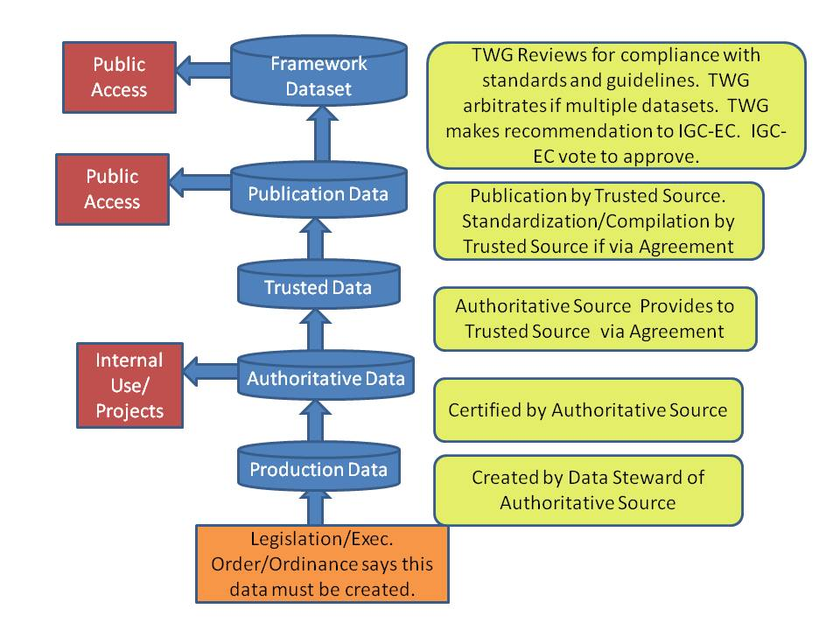

Appendix B – Example Nomination Form

Data Nominated By:

Framework Data Theme:

Framework Dataset:

Proposed Framework Dataset Name:

Link to Publication Dataset of Proposed Framework Dataset:

Link to Metadata of Proposed Framework Dataset:

Authoritative Source(s) Description (Include name of organization, contact information, and legal authority description)

Link to Data Exchange Standard:
http://gis.idaho.gov/portal/pdf/Standards/Themes/XXXXXXXX.pdf

Trusted Source Description (Include name of organization & contact information)

Please attach copies of the agreements between Authoritative Source(s) and Trusted Source.

Minimum Scale of Dataset:

Please describe the proposed maintenance schedule for the dataset:

If this dataset is not a statewide coverage, please describe the methodology for developing or incorporating other data to make a statewide coverage.

Other information for the IGC-EC to consider:

