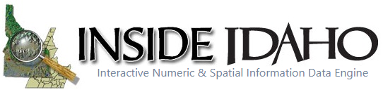

Publishers Supplement

## **BEST PRACTICES RECOMENDATIONS**

## **“Brand” Your ArcGIS Open Data Content**

### *Use Branded Thumbnail*

Branding promotes recognition. An easy way to brand your organizations content is to use thumbnails that have the same look and feel. Users will begin to quickly recognize your “branded” thumbnails and know they have found authoritative data from your organization. Here is an example of key pieces you may consider including in your item thumbnail:

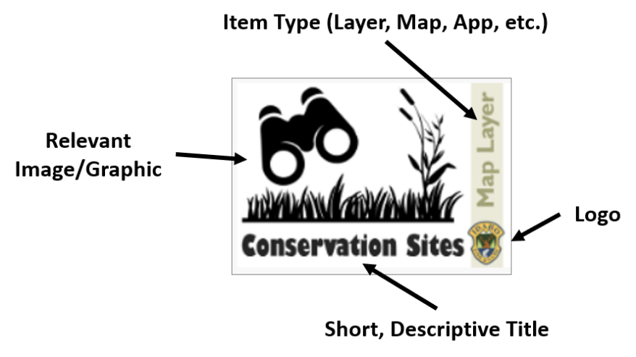

* **Your Logo** - consider this your authoritative stamp
* **Item Type -** Feature Layer, Tile Layer, Vector Tile Layer, Web Map, Map App, 3D Scene, Story Map, PDF, CSV, KML, Image, Tile Package, etc. [Items You Can Add to ArcGIS Online](https://doc.arcgis.com/en/arcgis-online/reference/supported-items.htm)
* **Relevant Image** - **IMPORTANT:** Use one of your organizations images or search online for an image/graphic that is licensed for reuse with modifications. Two ways to do this:
  1. Search Google and go to ‘Images’. Select ‘Tools’ and select ‘Labels for reuse with ‘modification’ from the ‘Usage Rights’ dropdown.

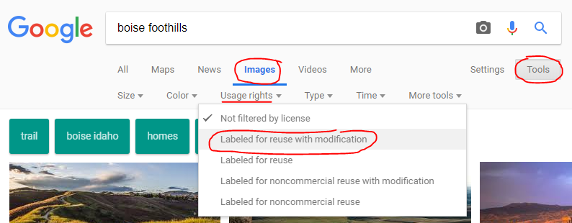

* 1. In PowerPoint, go to the ‘Insert’ tab and select ‘Online Pictures’. Search Bing and make sure ‘Creative Commons only’ is chosen.

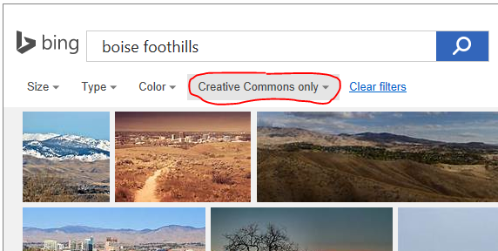

* **Short, Descriptive Title** - try to use the same title as your item. If your item’s name is quite long, try to simplify here to conserve space. (**NOTE**: The title doesn’t have to your organizations name, especially if it is included on your logo.)

Something else to keep in mind - your publicly-shared ArcGIS Online content is also discoverable on the larger, [ArcGIS.com](http://www.arcgis.com) website. That means if someone went to ArcGIS.com and searched for ‘Idaho Campgrounds’ they may find items that were not published by the authoritative source, in this case Idaho Parks and Rec. “Branded” content will help it stand out from all the rest.

### *Author Complete Item Information*

It is important to also provide good metadata about your published item. Navigate to your item’s ArcGIS Online ‘**Overview**’ page and fill in the following information:

* ‘**Title**’ - edit so it is no longer in camel case or have underscores, if necessary. The title is the name people see when they access the item and the name you see on the My Content tab on the content page. The title should represent what the item contains.
* ‘**Summary**’ - this may not be necessary if you already added a summary when publishing. This short description is returned in the results list when people search for content in the website.
* ‘**Description**’ - provide a longer narrative describing the content item such as creation history, current/completeness status, explain attribute fields, include links to other relevant resources such as organization webpages, etc. You may be able to simple copy and paste the description from the items metadata file, if it already exists.
* ‘**Terms of Use**’ - this section provides information about how the item can be used and by whom. For example, you might have a use constraint for a map layer that requires others to display copyright information on any screen capture that includes the layer.
* **‘Categories’ & ‘Tags’ -** it is also a good idea to assign your item to a category and provide tags. These pre-defined categories and tags pertinent to your item will help users discover your item. On the right-hand side, select one or more ‘**Categories**’ (if your organization has set them up). Edit the item ‘**Tags**’ by listing keywords associated with the item.
  + **NOTE:** If your data layer is an official Idaho Framework layer ([gis.idaho.gov/framework](https://gis.idaho.gov/framework/)), please work with Bruce Godfrey ([bgodfrey@uidaho.edu](mailto:bgodfrey@uidaho.edu)) to apply an appropriate tag so that it will populate on the INSIDE Framework page ([insideidaho.org/apps/browse-framework](https://www.insideidaho.org/apps/browse-framework/)).
* ‘**Credits (Attribution)**’ - you may choose to just use your organizations name or add more refined information like department.

**BONUS:** You can check to see if you have provided quality information by checking out the ‘**Item Information**’ section on the right-hand side of the ‘**Overview**’ page. This section can help you identify missing or incomplete item information and provides suggestions for improving it, such as adding more tags or a summary. Click the ‘**Top Improvement**’ suggestion to go directly to the section where you'll make the biggest impact or click ‘**Learn more’** to make your way through a full interactive checklist of suggested improvements. As you make improvements, such as adding terms of use or making the description longer, the checklist tracks the sections you updated and the status bar changes to reflect your progress. For example, this shows the layer is missing Terms of Use:

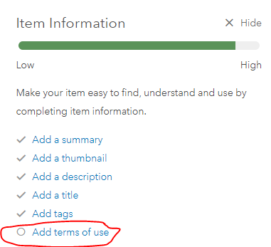

A good example of an item with complete item information: [Dams of Idaho](https://www.arcgis.com/home/item.html?id=e163d7da3b84410ab94700a92b7735ce).

### *Allow Others to Export Your Data (Feature Layers)*

* Through ArcGIS Online
  + Hosted - check ‘Allow others to export…’

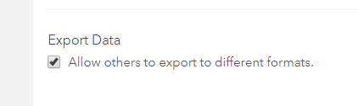

* + ArcGIS Server - must enable **Feature Access** capability with EXTRACT option enabled while publishing the Map service in ArcGIS Server.

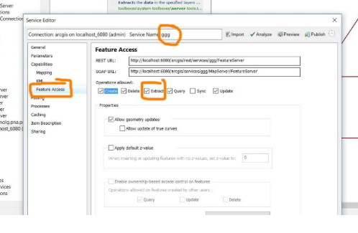

### *Share Your Content*

To share an item, you can:

* go to an individual item’s ‘**Overview**’ page and click the ‘**Share**’ button on the right-hand side
* go to your ‘**Content**’, check the box(es) next the item(s) you want to share, (you can share multiple items simultaneously by checking multiple boxes), and click  --> ‘**Access**’.

In the dialog box that appears, check the boxes next ‘Everyone (public)’ and your Open Data group(s) to share your data through INSIDE.

* **Everyone (public):** means just what it says, it will be discoverable by anyone searching ArcGIS.com.
* **[Your Organization]:** only your organizations staff with organizational ArcGIS Online user accounts will be able to see the item.
* **Groups:** share items with an existing group, [specify groups for Open Data](https://doc.arcgis.com/en/hub/data/specify-groups-for-hub.htm).

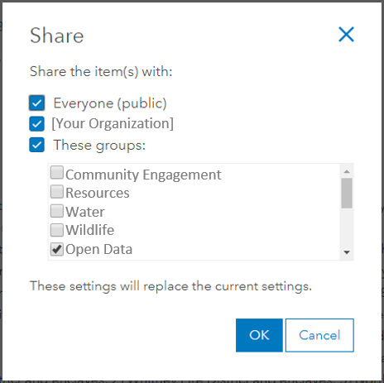

You can use multiple groups to share data through Open Data, and consequently INSIDE. If you use multiple groups, INSIDE will honor those groups. For example:

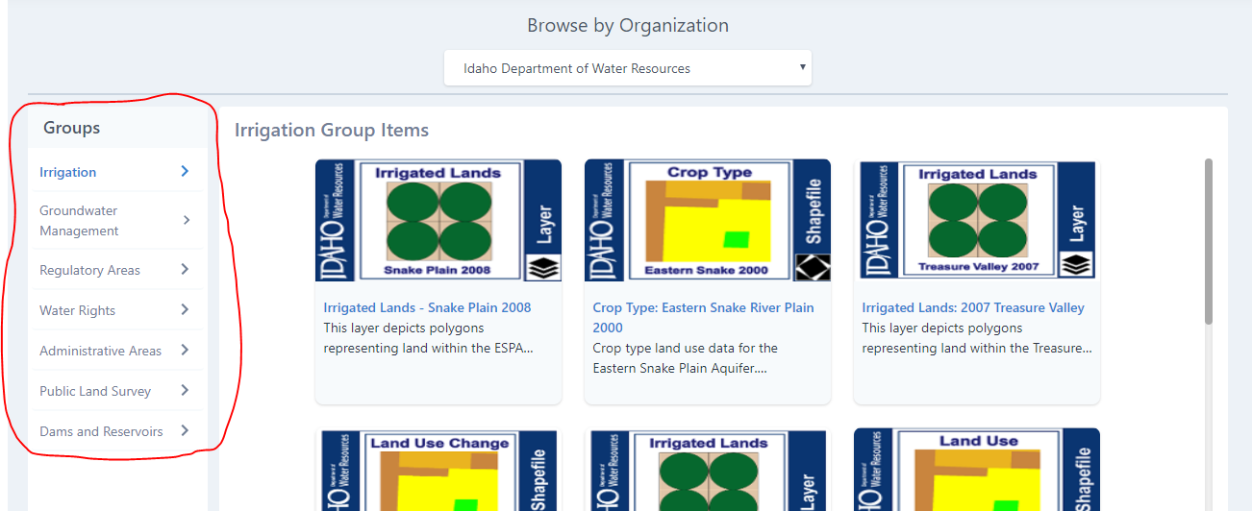

## **BEST PRACTICES CHECKLIST**

# Use Branded Thumbnails that includes:

* **Your Logo**
* **Type** – Feature Layer, Tile Layer, Web Map, PDF Map, CSV, Story Map, etc.
* **Relevant Image** – only use your own images/graphics or those licensed for reuse
* **Short but Descriptive Title**

# Author complete Item Information That Includes:

* **Title** - short but descriptive
* **Summary** - short description of the data/map/app
* **Description** - longer description of the data/map/app, could copy from source metadata
* **Terms of Use** - include your standard terms of use/liability disclaimer
* **Category**- pick at least one pre-defined category (if your organization uses them)
* **Tags** - list a few good keywords as tags. (contact Bruce Godfrey if Idaho Framework layer)
* **Credits** – most likely the name of your organization and maybe department, if relevant

*Use the **‘Item Information’** indicator to make sure your information is complete.

# Allow Others to Export Your Data (Feature Layers):

* From the feature layers content page, click the **‘Settings’ tab**, scrolls to the ‘Feature Layer Settings’ section, click **‘Allow others to export to different formats**’, and then click ‘Save’.



# Share Your Content:

* Share with **Everyone (including the public)** and your Open Data **Group(s).**

*Revision History:*

Draft 9/16/2019 pb